**1. Project Title** Cell Block Manager

**2. Problem in Brief**

* Currently, there’s very poor communication between RNO team requestor and INOC team leader and most of the time INOC team leader is not aware of their request.
* When considering the current system, the occurrence of human errors is ordinary and it is hard to handle manual data.

**3. Proposed Solution**

* We are going to develop a system that facilitates the interconnection between the RNO team requestor and the INOC team leader by introducing a web-based application.
* It requires a central system to monitor and handle cell block requests properly.
* Maintain cell block requests.
* Monitor the response of the cell block requests.
* Clear view and searching facility of the block requests.
* Follow up pending works (pending approval, pending block, pending unblock).
* Provide the beep tone in new pending works.
* Analysis of cell block request (request count, block pending request count, deblock pending request count, block count, deblock count).
* INOC team leader marks the request, block or unblock by the system and sending the email to the requestor.
* Vendor block requests need to be processed through the RNO team requestor. so, through this website, the RNO team requestor can view vendor requests and approve the process.

**4. Requirements identification**

4.1   Functional requirement

* Add and remove requests by RNO team requestor and vendor (single request or multi request).
* The vendor requests approval by the RNO Team requestor.
* View all requests and responses of the requests.
* View and playing beep tone the new pending block and deblock counts.
* Keep records and update records of the cell block details (block or unblock).
* Update cell block request single and multi-selection (block or unblock).
* Search request, view all requests in the log table, view complete requests highlighted.
* Mail and SMS function-> A message is sent to the requestor about the response of the cell block request.
* Can export the records (date range or all records as the excel sheet).
* View the analysis of cell block requests (request count, block pending request count, deblock pending request count, block count, deblock count).

4.2 Non-functional requirements

* Usability (Color combination is valid for even color-blind people, User interface responsive to any device).
* User-friendliness – adding icons and information messages.
* Increasing performance (AJAX form submit use to data insert and search, using table plugging).
* Security- prevent unauthorized access and SQL injection by using security functions.
* Data adding and updating are not reflected in other accounts.
* Reliability.

4.3 User levels

* Admin
* INOC Team Leader
* RNO Team Requestor
* Vendor

4.4 User Roles

* Admin
* Admin can handle every user detail including insert, delete and update.
* Show the pending requests count.
* Search the details of the cell block requests.
* Add or update cell block requests.
* Export the excel sheet.
* View the analysis of cell block requests.
* Add users and reset the password.
* INOC Team Leader
* Show the requests pending count.
* Search the details of the cell block requests.
* Update cell block requests. (block or deblock)
* Sent a message to the requestor about the response of the cell block request.
* Export the excel sheet.
* View the analysis of cell block requests.
* RNO Team Requestor
* Add the requests (single request or multi requests).
* Remove the wrong requests.
* View all user's requests and responses of the user requests.
* Show the pending approval requests.
* Give approval to the vendor requests.
* Vendor
* Add the requests (single request or multi requests).
* Remove the wrong requests.
* View all requests and responses of the user requests.

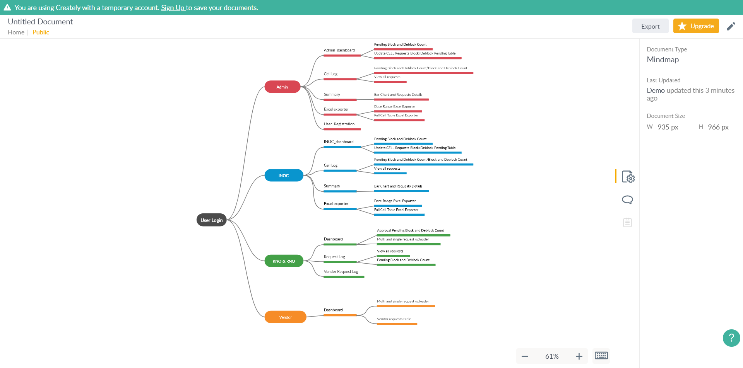

**5. Interfaces**



Figure 1: User Login

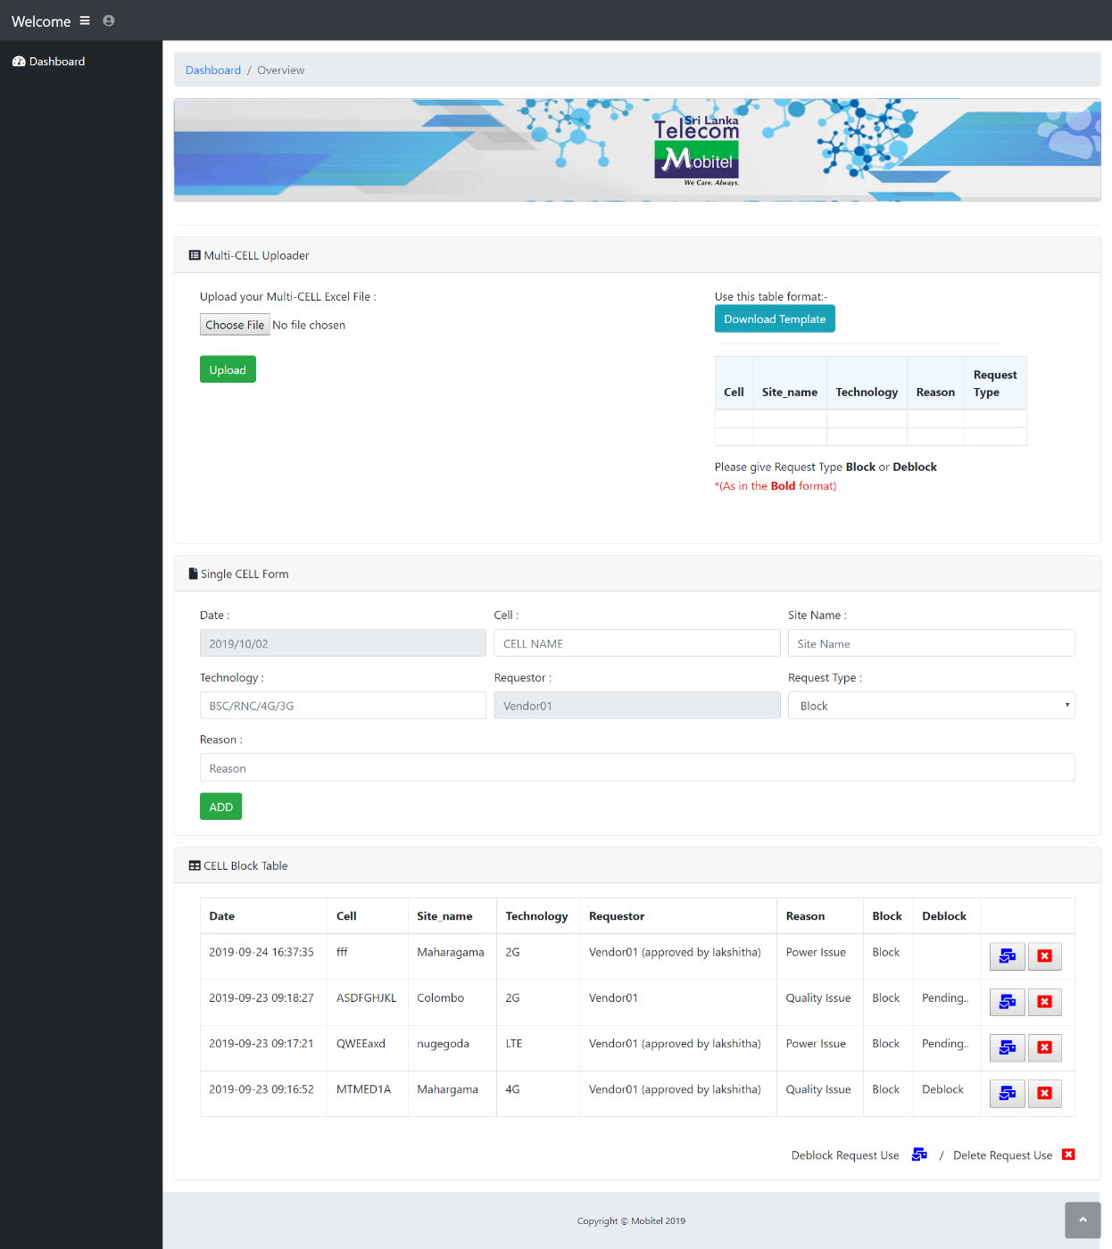

Figure 2: Vendor Dashboard

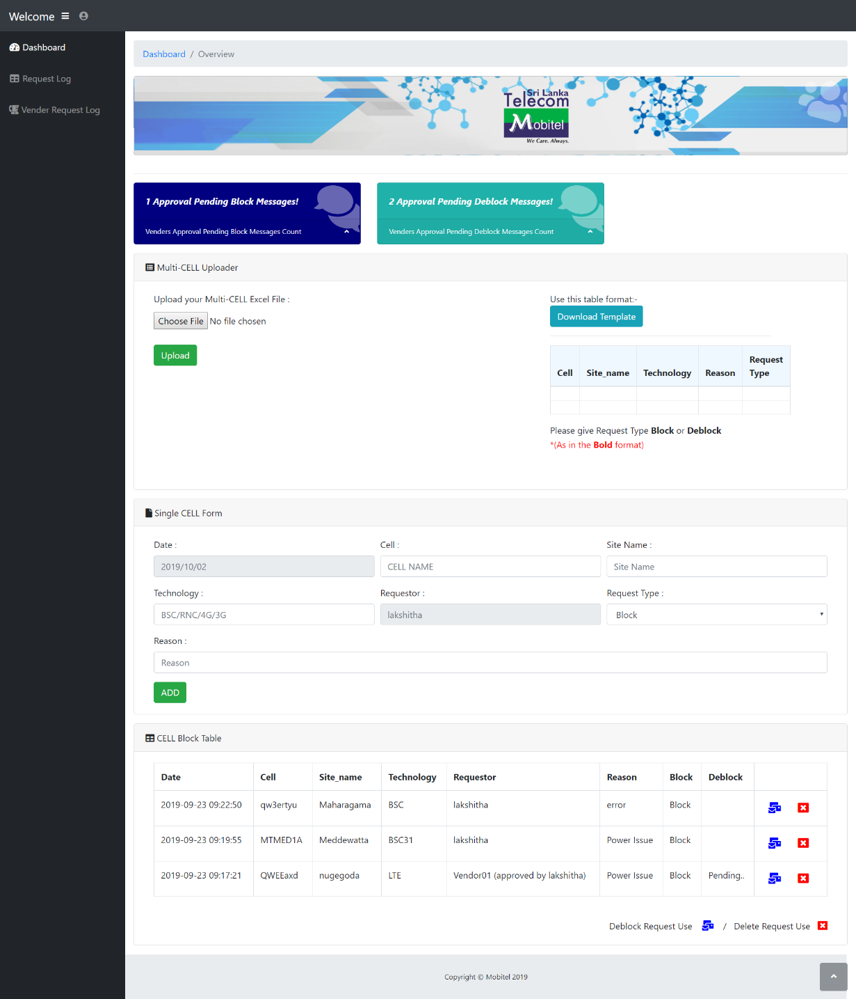

Figure 3: Requestor Dashboard

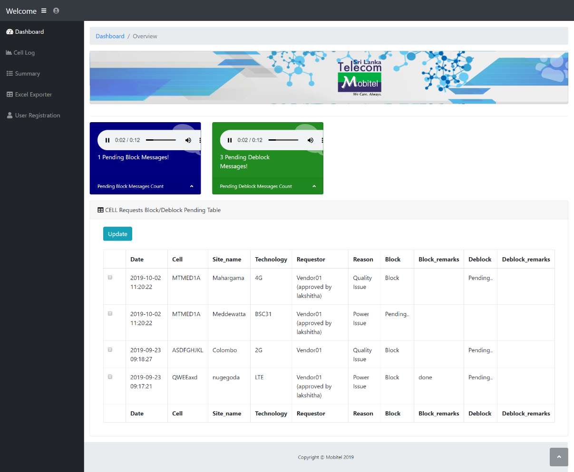

Figure 4: INOC/Admin Dashboard

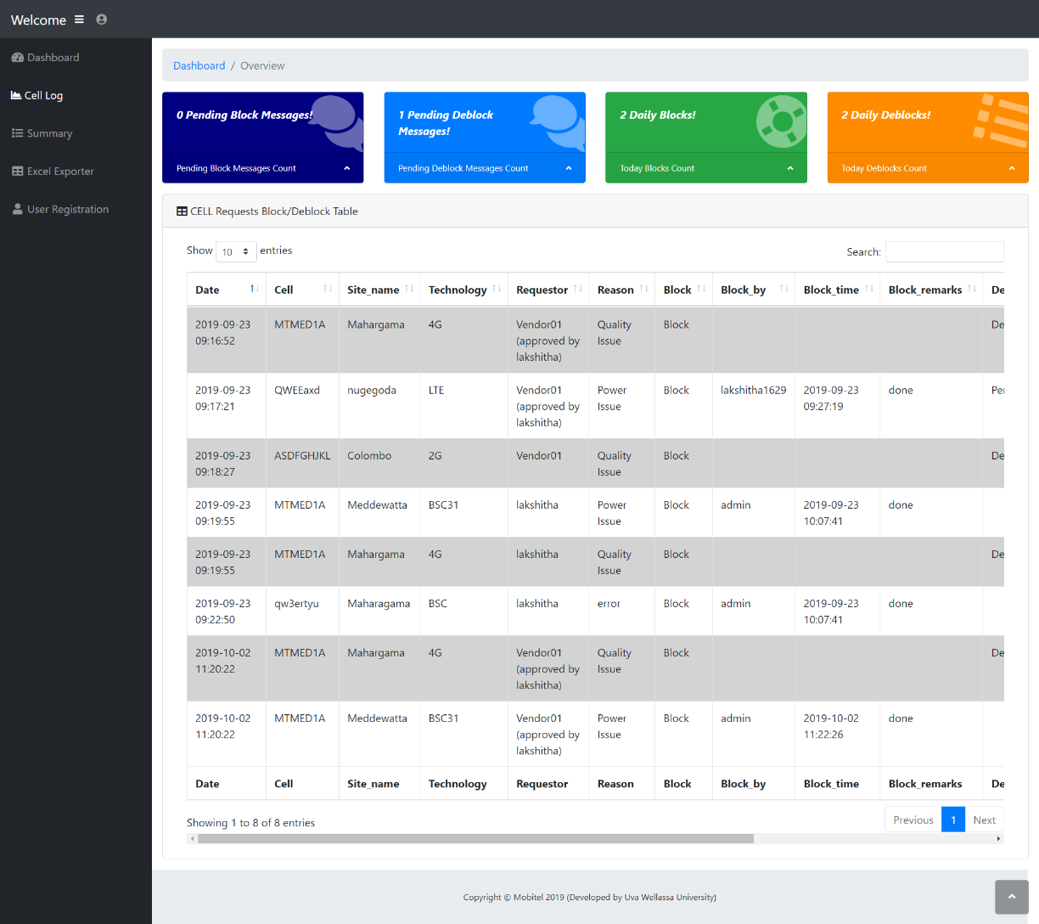

Figure 5: INOC/Admin Cell Log

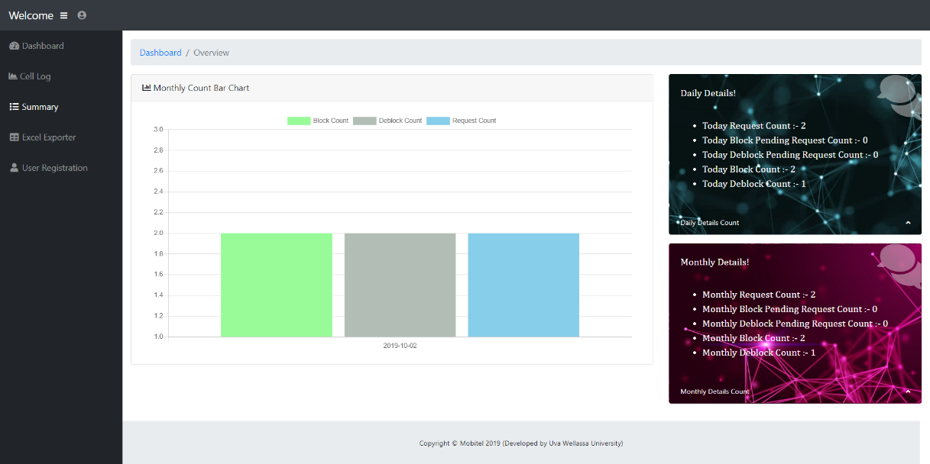

Figure 6: INOC/Admin Summary

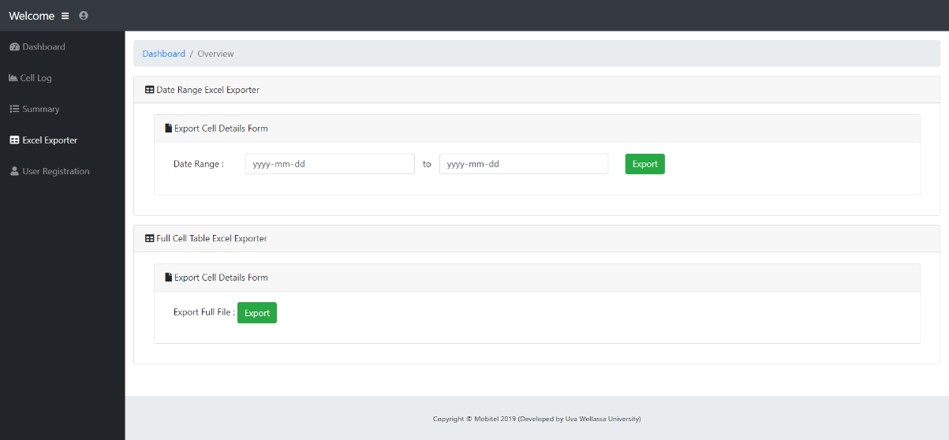

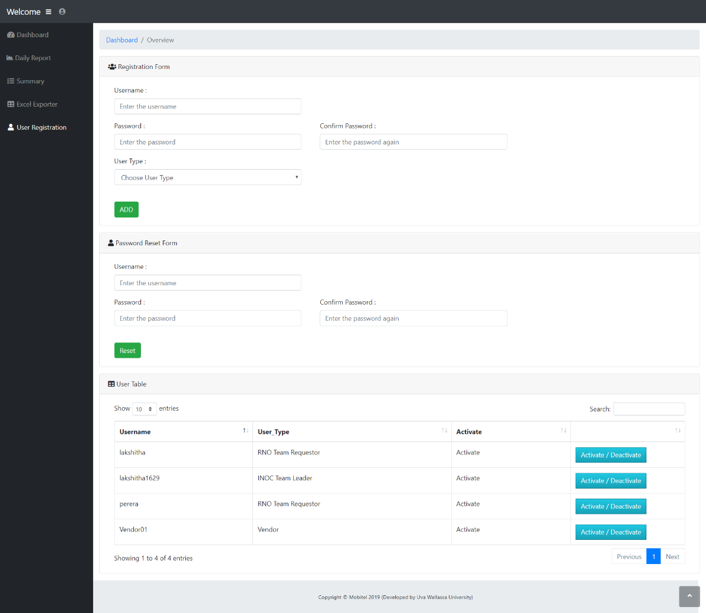

Figure 8: User Registration

Figure 7: INOC/Admin Excel Exporter